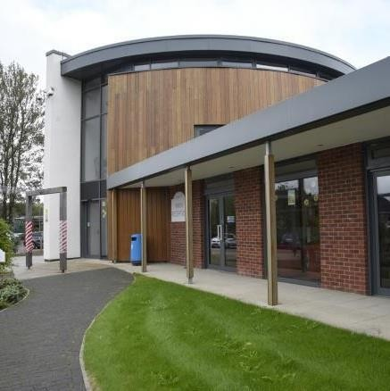

Annual Quality Account
2024 - 2025

TABLE OF CONTENTS

Welcome to the Bury Hospice Quality Account for 2024/25 4
Our Mission 4
Our Vision 4
Statement on Governance and Public Benefit – how we serve the population of Bury 6
Our Strategic Ambition 8
Quality Assurance 8
Care Quality Commission Quality Monitoring 9
Equality, Diversity, and Inclusion 9
Workforce profile (31 March 2025): 10
Patient/Service User Data: 11
Hospice Services 13
Inpatient Unit 13
Hospice Liaison Nurse & Outreach 13
Education 14
Complementary Therapy 14
Bereavement and Wellbeing Service 15
Staff Education and Mandatory Training Compliance 16
Patient Safety 17
Infection Prevention and Control 17
Incidents 17
Safeguarding 18
National Quality Indicators 19
Inpatient falls: 19
Pressure Ulcers: 20
Venous Thrombo-embolism: 21
Mortality: 21
Medication: 21
Controlled Drugs Incidents: 22
Audit 23
Local Audits: 23
Research (MANDATORY STATEMENT) 25
National Audits 25
Use of the CQUIN Payment Framework (MANDATORY STATEMENT) 25
Secondary Users Service (MANDATORY STATEMENT) – 25
Clinical Coding Audit (MANDATORY STATEMENT) – 25
IT, Data and Cyber Security 26
The Data Security and Protection Toolkit (DSPT) (MANDATORY STATEMENT) 26
Significant achievements in IT, Data and Security this year include: 27
Retail 28
Financial Summary 30
Our Impact on the Local Community: Beyond Clinical Care 30
Patient Care Support Services 31
Facilities 31
Housekeeping Team 32
Catering 32
Volunteering 32
Volunteer recruitment 2024 – 25: 33
Patient Experience 33
What do people say about us? 34
Visitor Feedback 34
Complaints / Concerns and Compliments 35
Patient Story 36
Priorities for 2025 - 2026 39
Statement from Stakeholder Organisation 40


Statement of Assurance from the Board of Trustees Chief Executive Stuart Richardson and Chris Clayton-Butler Chair of Board of Trustees of Bury Hospice


Welcome to the Bury Hospice Quality Account for 2024/25
We are pleased to present the Bury Hospice Quality Account for the year 2024/25. This report outlines our achievements over the past year and sets out our ambitions for the future, supported by performance data and service insights. As Chief Executive and Chair of the Board of Trustees, we confirm that the contents of this report are accurate and that we fully endorse our organization’s ongoing commitment to continuous quality improvement and service excellence.

Our Mission
To facilitate the provision of compassionate and holistic specialist palliative and end of life care in Bury, making sure this is person centered and provided in a person’s preferred place of care.

Our Vision
We want everyone in Bury to receive compassionate and outstanding personalised support as they experience their palliative care and end-of-life and strive to fulfil their wishes as fully as possible.
We support a population of over 194,606 (ONS, 2022), in the Metropolitan Borough of Bury, in the north of Greater Manchester. It is a diverse area of six townships; Bury, Prestwich, Whitefield, Radcliffe, Tottington and Ramsbottom. We also accept patients who live ‘out of area’ if their local hospice cannot admit them. We are regarded as a community asset, delivering the palliative and end-of-life care needs of all communities within the Metropolitan Borough of Bury. The hospice is considered as the specialist ‘hub’ for palliative and EOL care in Bury and is leading the shape of the Bury ambitions and care delivery pathways.
We maintained our 'Good' rating under the Care Quality Commission monitoring framework. The quality of our services and practice is monitored and reviewed by our Clinical Governance Committee which reports directly to Bury Hospice Trustee Board.
We continue our commitment to working in partnership with other healthcare organisations to improve quality, increase access to services, and help to build a strong and sustainable Integrated Care System in Bury and across the Greater Manchester Integrated Care Board footprint.
Looking ahead, Bury Hospice is committed to strengthening and influencing palliative care provision across Bury and the surrounding communities. Our strategic objective in 2025/26 remains to continue to review and adapt our existing services guided by the patients and families who trust us with their care, using our resources carefully to sustain care provision, improve our facilities and work even more collaboratively with colleagues in the wider health and social care system to promote equitable access to hospice care and to reduce unnecessary hospital admissions at the end of life. Our vision is for more people to be able to die in their preferred place, with the dignity and care they deserve.
Our people are at the centre of this vision. We continue to invest in professional development, foster collaboration, and refine our model of care so we can meet the evolving needs of our community, now and into the future.
I confirm that to the best of my knowledge, the information contained within this Quality Account is a true and accurate account of quality standards at Bury Hospice."

We welcome your comments and feedback on this Quality Account, which you can do via email, letter or telephone to Stuart Richardson, CEO. He may be contacted by telephone: 01617259800, or by email at stuartrichardson@buryhospice.org.uk

Please address correspondence to Stuart Richardson, Bury Hospice, Rochdale Old Road,
Bury BL9 7RG.

Charity number: 1136843

Statement on Governance and Public Benefit – how we serve the population of Bury
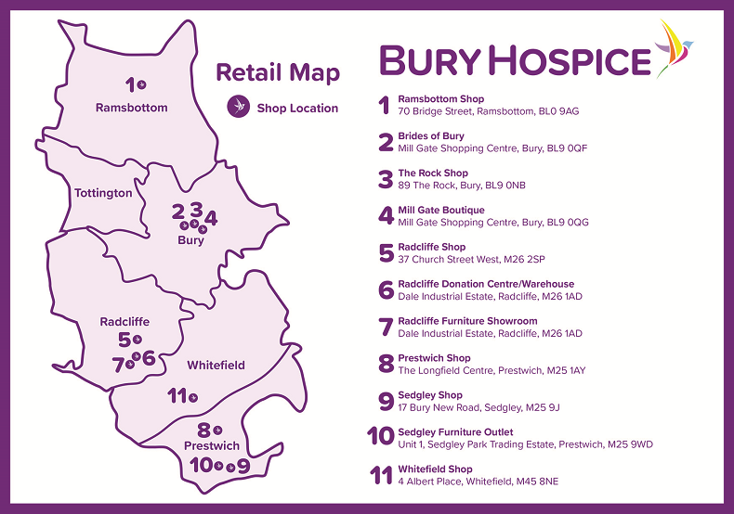

Bury Hospice cares for patients (over the age of 18) who are living with life-limiting illnesses, while also providing vital support to their families and carers. Our compassionate, dedicated multi-disciplinary team includes Nurses, Doctors, Allied Health Professionals, Complementary Therapists, Psychological Support Staff, and Dementia Specialists.
We work closely with local hospitals, community services, social care providers, and voluntary organisations to ensure every patient receives personalised care that is unique to their needs. Our support extends to patients, families, and loved ones throughout the entire journey — from diagnosis, through treatment, and beyond.
Based at our hospice in the heart of Bury, we offer a wide range of services both on-site and in community, through our Outreach team which delivers care and support in the comfort of a patient’s own home, enabling them to remain in a place of their choosing at the end of their life.
We support a population of over 190,000 (ONS, 2018), in the Metropolitan Borough of Bury, in the north of Greater Manchester. It is a diverse area of six townships; Bury, Prestwich, Whitefield, Radcliffe, Tottington and Ramsbottom. We also accept patients who live ‘out of area’ if their local hospice cannot admit them.
We are regarded as a community asset, delivering the palliative and end-of-life care needs of all communities within the Metropolitan Borough of Bury. The hospice is considered as the specialist ‘hub’ for palliative and EOL care in Bury and is leading the shape of the Bury ambitions and care delivery pathways.
Our specialist and dedicated services include eight bedded Inpatient Unit (IPU) with the capacity to increase in size if required, community outreach and bereavement/holistic support services.
It costs around £4.9 million to run Bury Hospice each year, and with only a 17% contribution from the NHS, with the remainder being raised through our charitable income generation and retail offer that spans across the Borough, so every single donation makes a difference. Our income generation team works nonstop to keep our doors open, alongside our staff who also donate their time to individually fundraise and volunteer at fundraising events – just one of the many reasons why our hospice is such a wonderful place to work.

We recognise and value the key role volunteers play in enabling a thriving and successful hospice and we are proud of the fact that we have a dedicated team of volunteers covering both clinical and non-clinical services across the whole organisation.

Governance of the Organisation: The Board, currently made up of 14 Trustees, who have ultimate responsibility for the governance of Bury Hospice. The Board is responsible for all major strategic decisions, for monitoring the organisations performance, and to ensure that it complies with its Articles of Association and applicable laws and regulations.

Our Strategic Ambition
Our ambition to continuously improve our services as well as our efficiency, and effectiveness is embedded in our culture, plans, and personal objectives.
We will demonstrate our commitment by using data from patient and family feedback, incident reports, and front-line experiences to change the way we do things, achieving better outcomes for those who need our support.
We will be formally reviewing existing services to ensure they are meeting needs within the current funding envelope and to give us an indication of the resources required in future years to address growing demand or enhancement of these services.
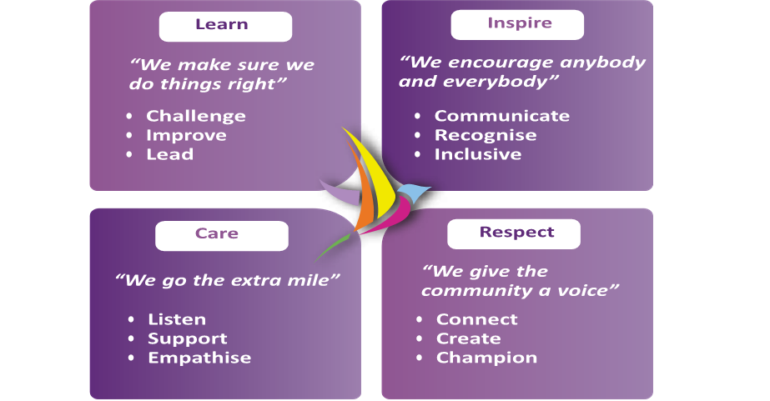

Quality Assurance
At Bury Hospice, our skilled clinical team is central to delivering compassionate, specialist end-of-life care. With advanced training and experience, they manage symptoms, provide pain relief, and support patients and families with dignity and comfort.
Beyond their expertise, staff bring empathy and understanding to every interaction—guiding difficult conversations, building meaningful connections, and offering reassurance at a profoundly significant time.
Our workforce truly embodies our values of Respect, Care, Learn, and Inspire, enabling us to deliver high-quality care while working with partners, supporting families, and championing the vital role of hospice services in our community.

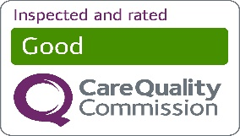
Care Quality Commission Quality Monitoring

Bury Hospice is registered with the Care Quality Commission (CQC) to provide the following services: Treatment of disease, disorder, or injury.

In 2023, the CQC introduced a new inspection framework focused on person-centred care, learning, and safety. Bury Hospice remains committed to compliance across the five domains: Safe, Effective, Caring, Responsive, and Well-led. Between 19 August and 5 September 2024, inspectors assessed us against eight quality statements within the Safe, Effective, Responsive, and Well-led domains.

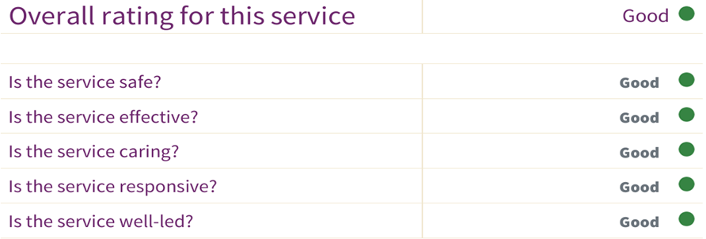

The inspection found no regulatory breaches, and Bury Hospice retained its “Good” rating. Inspectors highlighted our high-quality, compassionate care, with patients and families consistently praising the skills, kindness, and dedication of our teams. The report also commended our patient-centred approach—effective pain management, clear communication, and involving people in decisions—as well as the significant impact of our bereavement and family support services.

This result demonstrates that our strategic focus on building strong foundations has been successful and supports our vision to ensure all patients and families in Bury receive outstanding, compassionate care throughout their palliative and end-of-life journeys. We continue to hold regular quality reviews with Integrated Care Partnership (ICP) colleagues, who remain pleased with our performance.

Equality, Diversity, and Inclusion
Bury Hospice fosters a compassionate, inclusive culture, promoting equality of access, experience, and outcomes for patients, carers, staff, and the wider community. We value diversity and ensure everyone feels welcome and respected.
As both a healthcare provider and employer, we meet our legal duties under the NHS Constitution, Care Quality Commission standards, and legislation including the Equality Act 2010, Human Rights Act 1998, Mental Capacity Act 2005, and Health and Care Act 2022.
Our principles:
- Equality – ensuring fairness and preventing discrimination.
- Diversity – recognizing and valuing individual differences.
- Inclusion – creating a culture where everyone belongs.
- Discrimination – challenging negative attitudes and behaviours that disadvantage people.
We collect equality monitoring information (e.g., age, ethnicity, religion) to better understand and meet the needs of our community. All data is held securely, anonymised for reporting, and analyzed to address inequalities, particularly for minority and disadvantaged groups.
We use workforce equality data to strengthen our inclusive culture and recruitment processes, supported by:
- Workforce Race Equality Standard (WRES)
- Workforce Disability Equality Standard (WDES)

Workforce profile (31 March 2025):
As of the 31st March 2025, the organisations gender make-up continues to be female in the majority, at 87% female and 13% male.
The age range of our staff is detailed in the table below, with the 50 – 69 age groups making up a total of 53% of our workforce:

The ethnic background of our employees showed that 40% had not declared their ethnicity and the biggest percentage identified as White-British (55%).

The Hospice operates a fair, inclusive, and non-discriminatory recruitment process, selecting candidates solely on their suitability for the role, as defined by clear job profiles, person specifications, and transparent interviews.
Vacancies are widely advertised to reach all sections of the community, and all applicants complete an equal opportunity monitoring form. Where under-representation is identified, we will, where appropriate:
- Positively encourage applications from those groups.
- Advertise through channels that reach them, including specialist media.
- Request guidance from agencies such as Job Centre Plus.
- Certify selection principles remain entirely job-related.
- Review policies and practices and consider targeted training for underrepresented groups.
In line with legislation, the Hospice may take positive action to support people with protected characteristics to access employment and services on an equitable basis.

Patient/Service User Data:
The age profile of Bury Hospice patients is weighted towards older adults, with minimal representation under forty-five. The largest groups are aged 65 and above, peaking in the 75–84 range, followed by those aged 85 and over. The Hospice continues to review service accessibility to ensure that people of all ages can benefit from appropriate care and support.

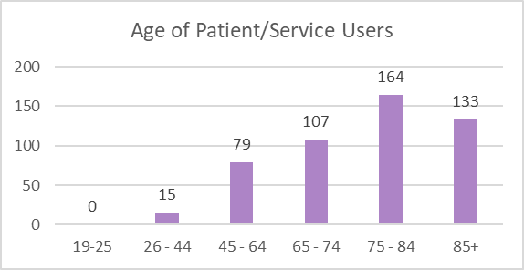
In the 2024–25 period, 84% of Bury Hospice patients identified as White, with 4% from other ethnic groups, 1% declining to specify, and 11% unknown. By comparison, the 2021 Census shows that 82.9% of Bury’s general population identified as White.
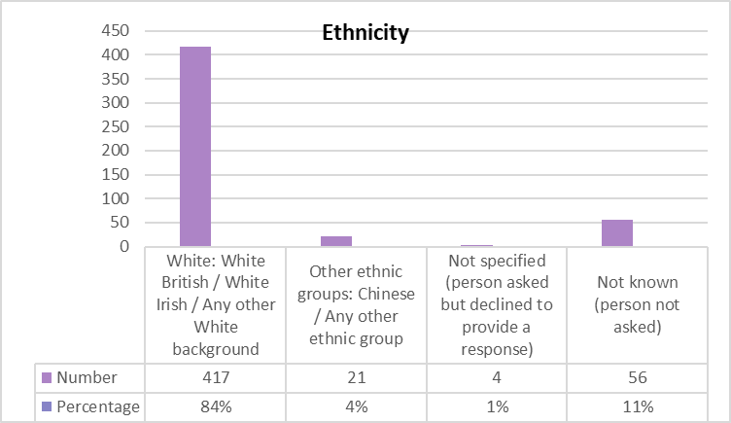
That suggests the hospice’s patient ethnicity profile is broadly in line with the local population, though patients from non-White groups appear slightly under-represented.

In some cases, ethnicity is not recorded for hospice patients due to clinical priorities at the point of admission, the sensitivity of timing, or the patient’s condition preventing completion. Data may also be missed through administrative oversight or if patients, families, or carers decline to provide this information. The Hospice continues to encourage and support full data collection wherever possible, to strengthen equality monitoring and ensure services meet the needs of all communities.

Hospice Services
Our hospice clinical teams delivered timely, compassionate care through the inpatient unit, outreach, liaison, complementary therapy, and bereavement services. Our education team also partnered with health and social care providers to deliver training, extending the hospice’s impact across the community.
There have been some fantastic patient stories over the last twelve months, evidencing the positive impact that all our hospice services make. The key themes from these are:
- Compassionate communication: Patients and families have highlighted the positive impact of being heard and understood during emotionally difficult periods
- Personalised care: Stories reflect strong adherence to patient values, including religious and cultural preferences, advance care planning, and spiritual support
- Integrated teamwork: Multi-disciplinary approaches have resulted in seamless transitions between hospice services and external partners (e.g. district nurses, GPs)
- Challenges noted: Some delays in community night-time symptom control were reported. In response, the Hospice Liaison Nurse has worked with community partners to enhance night support and improve hospital discharge handovers.

Inpatient Unit

The IPU saw 179 admissions in 2024/25, a 15% rise from last year.

Average stay fell from 14.4 to 13.3 days, while referral-to-admission time rose slightly (1.0 to 1.8 days), reflecting wider system pressures and growing community demand—supporting our case to open four additional beds. Families continue to receive keepsakes, hand castings, and cuddle tops, offering comfort and early bereavement support.

Hospice Liaison Nurse & Outreach

The HLN strengthened links between hospice, hospital, and community services, handling 1,147 contacts (up from 552) while onward referrals decreased, demonstrating greater support for patients to remain in their preferred place of care.
The Outreach Service supports adults with life-limiting conditions to stay at home, providing early intervention, symptom management, advance care planning, and respite for caregivers.


In 2024/25, the team completed 1,640 face-to-face visits (down 11%) and 1,173 phone contacts (up 10%), reflecting proactive caseload reviews and effective integration with GPs, hospitals, and community services.

Education

Bury Hospice expanded its education programme, offering on-site training for both hospice and external staff. Specialist sessions covered Advance Care Planning and clinical care as part of the Palliative Care Passport.
In 2024/25, the Lead Educator trained 127 internal staff (including four completing the education passport) and 130 external staff (including two completing the education passport). The hospice also hosted placements for medical, nursing, paramedic, cadet, and allied health students.
Together with the Patient Liaison Nurse, the Lead Educator delivered six hospice awareness sessions to health, social care teams, and the community, broadening understanding of hospice care and support.
- Bury Hospice has continued to develop its education offer through the provision of on-site training that can be accessed by hospice and external staff.
- The hospice is providing specialist training to the system on Advance Care Planning and specific aspects of clinical care as part of the Palliative Care Passport.
- The Lead Educator delivered training for 127 internal staff, including four members of staff who completed six sessions for the education passport.
- Training was also delivered to 130 external staff members, including two individuals who completed six sessions of the education passport.
- Bury Hospice continues to be proactive in supporting education of our health and social care partners through the provision of placements for trainees, from medical, nursing, cadets, paramedics, and other student Allied Health Professionals.
- The Lead Educator and the Patient Liaison Nurse have delivered six hospice awareness sessions within the wider health and social care team, as well as the local community, making them knowledgeable about all aspects of the hospice and what care and support it offers.

Complementary Therapy

The Complementary Therapy team has provided 534 (3% increase) individual sessions to both patients and carers, which supports spiritual and psychological wellbeing, by encouraging mindfulness, reflection, and inner peace. This can help the individual to make sense of their experience, promoting meaning, acceptance, and dignity. Some therapies (e.g., Reiki or visualization) being chosen for their alignment with personal or cultural beliefs. The Complementary Therapy team has also provided 61 Lymphatic Drainage Massages to patients on the treatment pathways, which is a 7% increase.

Bereavement and Wellbeing Service

On a monthly basis, the Bereavement team facilitates two therapeutic bereavement support groups in the community, at different venues in Bury. These groups continue to be well attended, with an average of eight attendees each session.
The team also hosts a weekly Walk & Talk Group, which is equally successful, with an average of ten walkers enjoying the local sights each week.
This peer support work compliments the 1:1 counselling and emotional support provided to children, young people, and adults within the hospice.
The annual ‘Time to Remember’ service ran in September 2024 and March 2025, welcoming two hundred friends and family members in a safe and caring environment, allowing for reflection and support.
The Bereavement team has continued to provide therapeutic peer support for children aged 5-11 and their families via the Sunflower Group programme.
This group enables families to come together in their grief, share memories of their loved ones, explore feelings, and consider ways in which to promote resilience after loss. Two groups were supported, caring for nine families with a total of thirteen children and the feedback was fantastic. Following on from these groups, the team invited attendees to a Sunflower Reunion event in December, with ten families joining and taking part in creative activities: reconnecting once again.
The Bereavement team continues to link in with external bereavement services to ensure people are well supported throughout their grief journey.
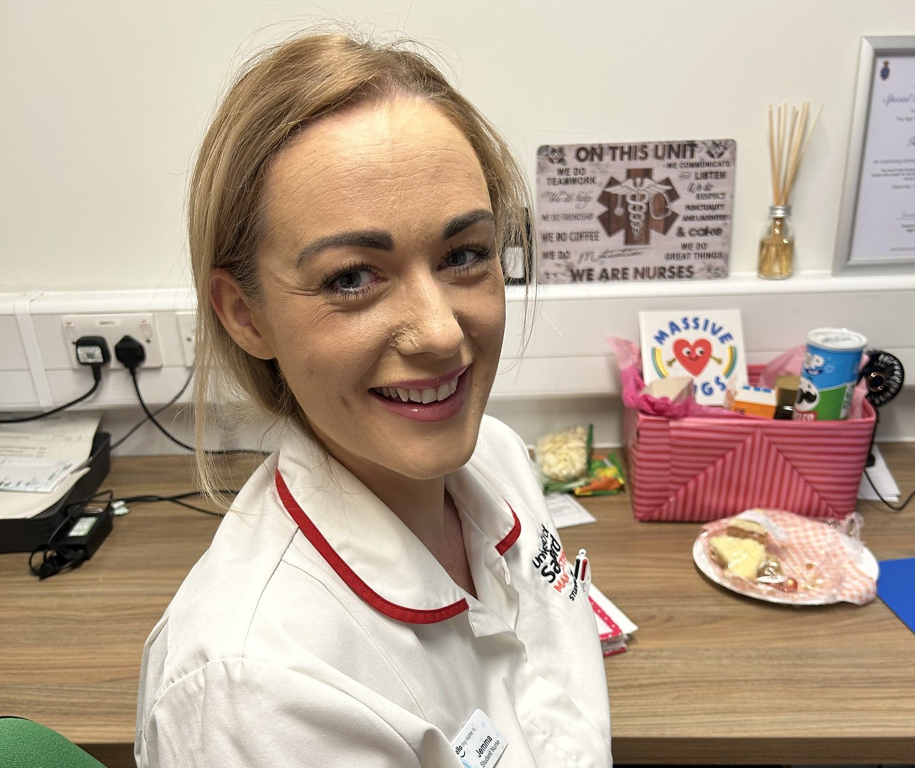
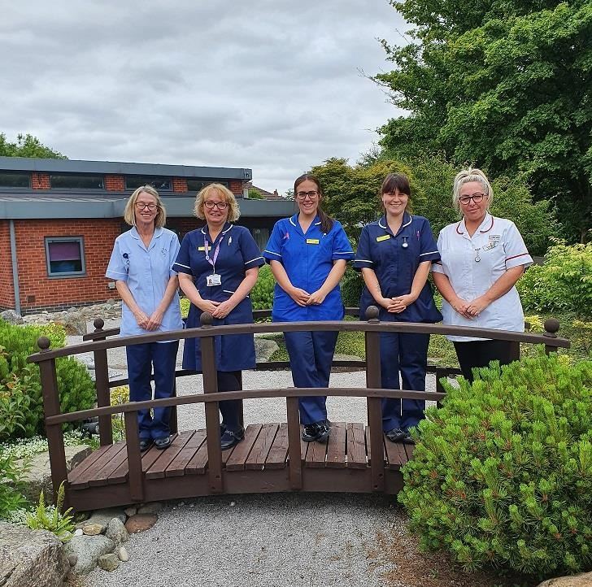
The team is proactive in supporting an external suicide support group, which runs at the hospice on a monthly basis, alongside attending any training and networking opportunities in this field.

Staff Education and Mandatory Training Compliance

Mandatory training compliance is monitored and reported through the Hospice Clinical Standards Group and the Clinical Governance Committee. The data is broken down into staff groups and where the area falls near or below the 90%, support is offered to highlight staff requiring training and consider how best to support completion of the training.
For the end of 2024 – 2025 the training records for core training show above 90% in all modules, which is excellent.

Note: the training rate decreased as new training modules were implemented.
Key training module compliance is detailed below, as of 31st March 2025.
Compliance Level – 90%, | Staff completed training | 2024 - 25
Safeguarding Adults at risk Training | Level 1 | 98%
Safeguarding Adults at risk Training | Level 3 | 96%
Safeguarding Children at risk Training | Level 1 | 98%
Safeguarding Children at risk Training | Level 3 | 96%
Mental Capacity |  | 93.3%
Dementia Awareness |  | 94%
Deprivation of Liberty Safeguarding (DoLs) |  | 90%
Mental Capacity Act |  | 93%
Whistleblowing |  | 99%
Supporting People with a Learning Disability – Tier 1 |  | 93%
Preventing Radicalisation |  | 99%

Patient Safety

Infection Prevention and Control
Throughout 2024/25, Bury Hospice has upheld its commitment to providing a safe and healthy environment for patients, families, staff, and volunteers. Infection prevention and control has remained a top priority, with robust protocols in place to minimise the risk of healthcare-associated infections. These measures are continually reviewed and implemented in line with the latest national and international guidance, ensuring that the highest standards of care and safety are maintained across our Hospice.
Our focus is on minimizing healthcare-associated infection risks while ensuring the health and wellbeing of all involved. Infection control practices are guided by evidence-based approaches, with ongoing monitoring and enhancement.
Surveillance Data April 2024 - March 2025
Clostridium difficile | 0
Norovirus/Diarrhoea | 0
Methicillin-resistant Staphylococcus aureus | 0
Vancomycin-Resistant Enterococci/Carbapenemase producing Enterobacterales | 0

Incidents
This year, Bury Hospice has adopted the Patient Safety Incident Response Framework (PSIRF) to enhance learning and improve patient safety processes. Aligned with NHS standards, this approach supports ongoing safety improvements.

Reporting and responding to incidents, accidents, and near misses is vital for patient safety and learning. Bury Hospice follows a system-focused approach aligned with the NHS Patient Safety Strategy (2021), ensuring compliance, timely action, and continuous improvement.

The Clinical Standards Group and the Clinical Governance Committee have met quarterly to review incidents, extract insights, and create action plans. Their proactive efforts drive continuous improvements in patient care.

During the reporting period from 1st April 2024 to 31st March 2025, a total of 440 internal incidents were reported. Of these, 331 (75%) were classified as clinical incidents, while 109 (25%) were non-clinical incidents.

Importantly, no Serious Untoward Incidents (SUIs) were recorded during this period, indicating effective risk management and prompt incident response processes across the organisation.

Clinical leadership fosters a culture where staff can safely report errors, prevent recurrence and enhance care. The Senior Leadership Team oversees all incidents, with findings reviewed by the Clinical Standards Committee and shared with the Clinical Governance Committee and Board of Trustees for transparency and robust governance.

This approach demonstrates to the Care Quality Commission that Bury Hospice is safe, effective, caring, responsive, and well-led.

Safeguarding
Safeguarding is one of the categories of incidents and is central to the Hospice’s culture, ensuring children and adults at risk are protected from abuse, neglect, and harm. In early 2025, our new Director of Clinical Services, Jenny Gallagher, became Safeguarding Lead, supporting staff and volunteers in recognising safeguarding as a shared, top priority. We uphold the highest standards by monitoring developments, raising concerns promptly with the Bury Integrated Care Partnership Safeguarding Team, and acting in line with the Care Act 2014.
Deprivation of Liberty Protection Safeguards (DOLs)= 1 | Safeguarding referrals = 4 (2 required no formal escalation & 2 had multiagency response. | Learning from Lives and Deaths of people with a learning disability and autistic people (LeDeR) notifications = 0

During 2024/25, there were no allegations made against staff at Bury Hospice.

National Quality Indicators
NHS Trusts are required to report performance against core indicators using nationally held data. Hospices do not submit this data, but despite this, we have measured our performance against the indicators that apply to the healthcare we provide, utilizing the Hospice UK benchmarking scheme. Hospice UK benchmarking has changed in 2024/5 in that it now compares performance data at a category level for pressure ulcers, medication incidents only resulting in severe harm or death and falls resulting in severe harm, death. This increases the value of benchmarking some metrics (Pressure Ulcers) and reduces it in others (Medication incidents).

Inpatient falls:
No falls at Bury Hospice resulted in severe harm or death. There were 31 falls on the in-patient ward affecting 22 patients. 9 falls resulted in no harm and 21 in low harm and one moderate harm.

To manage and reduce risks we:
- Held safety briefings as part of the clinical standards meetings where falls and their management are discussed, with case studies and learning, with good practice shared.

- Review of seating was completed and new reclining chairs and specialist seating is now in place. This has improved quality of life, comfort, and safety

Pressure Ulcers:
Hospice UK benchmarking since 2024 breaks down the new or acquired at hospice pressure ulcer data by category. The graphs below for the available data this year show new pressure at Bury Hospice by category

There were a total of 133 pressure related incidents reported, 47 found on admission and 88 developed during admission.

Of the 47 pressure-related issues identified on admission, 34 were graded 1–4, while the remaining 13 were classified as suspected deep tissue injuries (5), moisture lesions (5), and ungradable wounds (3).

During the hospice stay, 37 of the 88 total pressure-related incidents were outside the grade 1–4 category. These were predominantly suspected deep tissue injuries (26), with moisture lesions (6) and ungradable wounds (5) making up the remainder.

Most skin integrity issues developed during admission, reflecting the clinical complexity of hospice patients, many of whom have rapid deterioration and limited mobility. Pressure damage can result from poor nutrition, impaired perfusion, reduced mobility, and declining physiological function. Despite risk assessments, repositioning, and use of pressure-relieving equipment, disease progression can make some damage unavoidable.

Staff follow evidence-based practices, including regular assessments, individualised care plans, multidisciplinary review, and ongoing audits. Care is delivered compassionately, prioritising comfort, dignity, and quality of life. Interventions are discussed sensitively with patients and families, and when skin damage is unavoidable, staff focus on comfort, symptom control, and emotional support, reflecting the hospice’s person-centered ethos.

To manage and reduce the risk of pressure damage within the inpatient unit we take the following actions:
- All new Category III and above pressure ulcer incidents are reviewed by the Director of Clinical Services
- Inpatient Unit Clinical Lead and Director of Clinical Services review all Vantage incidents which report pressure ulcers
- A programme of education is being delivered over 2025 – 2026, focusing on identifying damage and skin changes, to trained nurses and HCAs

Venous Thrombo-embolism:
Our management in treating Venous Thrombo-embolism (VTE) risk was 100%.
- We follow VTE guidelines in accordance with national recommendations specificallyNICE Guideline 89 (section 1.4.13).
- We consider pharmacological VTE prophylaxis, taking into account temporary increases in thrombotic risk factors, risk of bleeding, life expectancy and the views of the person and their family members or carers.
- When appropriate, we use Low Molecular Weight Heparin as a first-line treatment and monitor daily. We do not offer VTE prophylaxis to people in the last days of life.

Mortality:
A hospice will have a higher mortality rate than other care settings with many individuals choosing a hospice as their preferred place of care and death.

All deaths which have occurred at the hospice have been reviewed by the Medical Examiner Service at Fairfield General Hospital, Northern Care Alliance NHS Foundation Trust. In 2024/25, there were no episodes of suboptimal care that contributed to or hastened a patient’s death.

Medication:
Due to the limitations of the benchmarking exercise, we cannot meaningfully compare ourselves against other hospices as most incidents at other hospices and at Bury Hospice are no or low harm and are not benchmarked by Hospice UK since mid-2024.
There were no medication incidents resulting in death at Bury Hospice or across the UK hospice sector.

To manage and reduce the risk of medication incidents or errors we:
- Monitor and review all incidents at ward level with robust investigations and support for staff, and any learning identified, key trends and mitigation are discussed at Clinical Standards and reported to Clinical Governance Committee, which has trustee representation.
- Working to implement electronic prescribing module E-Works which will reduce errors and support improved patient safety.
- Train all our nurses regarding safe medicines management as part of their induction and this is repeated every 2 years.

Controlled Drugs Incidents:
The CQC monitors governance of controlled drugs, with arrangements varying by organisation. At Bury Hospice, all incidents, including those involving controlled drugs, are reported and reviewed by the Controlled Drugs Accountable Officer (CDAO), who is our Director of Clinical Services. Significant incidents are escalated immediately to the CEO. Summaries are prepared for Clinical Standards and Clinical Governance Committees, with minutes shared with the Board of Trustees.
Within this period there were no catastrophic or major incidents reported and no reason for escalation to the Police, the Greater Manchester Local Intelligence Network (GM LIN) or NHS England.
There were 116 internal incidents/near misses involving controlled drugs reported to the LIN, of which 94% (109) were no harm and 7% (7) were low harm, with the majority being documentation errors, including missed signatures. All were investigated and learning from incidents disseminated as appropriate to relevant staff.

Audit

Local Audits:
As part of continuously improving the quality-of-care provision we conduct audits and service evaluations using where possible, nationally agreed hospice specific benchmarking tools. During the year, we have completed a number of quality and practice audits to assess our compliance and effectiveness in relation to national and local good practice guidance.

These audits are monitored through the Clinical Governance Committee, which reports to the Board for assurance at the highest level in the organisation.

An annual plan is agreed and scheduled at the beginning of each year, and usually, additional audits are included as identified from our monitoring and review processes linked to patients’ quality and safety.

The following are examples of audits (both clinical and non-clinical) conducted within the Hospice in 2024-2025:
Audit | Summary of results | To improve on | How
Oral Care Audit | The audit shows several strong areas of documentation, with some elements scoring 95% and 90% in the first oral care audit.  Oral care assessment logs are completed well, showing good compliance with recording assessments.  This audit serves as a baseline, as no previous oral care audits exist for comparison. | Improve nursing notes by completing 7-day updates, documenting changes, and recording oral care delivered.  Strengthen communication at huddles to ensure care plans are updated and standards followed.  Encourage staff to request oral care assessments from the Oral Palliative Care Nurse when needed. | Targeted staff training for documentation and review of handover process and documentation.  Increase staff participation in oral care study days.
Patients’ Own Drug Storage (PODs) | PODs are generally functional but would benefit from more consistent daily upkeep.  Some items found in PODs were not prescribed or being used rather were being stored.  Most liquid medicines were managed appropriately, though a small number of opened bottles were not dated. | Routine checks to ensure storage of drugs compliance. | To include in daily huddle and jobs allocation.
Outreach service Documentation | Outreach documentation remains strong with only minor omissions.  Marked improvements since last quarter, with 100% completion for ethnicity, assessments, care plans, and patient/family involvement.  Increased presence of blue records in patients’ homes.  Some areas remain at 95% (Next of kin, allergy status, care plans) where 100% is expected.  Current audit timing may limit full case review | Reinforce the need for complete, accurate documentation and share results with the team.  Raise consistently strong areas (95%) to 100% compliance.  Ensure all required documents and assessments are completed or uploaded.  Reschedule future audits to enable more effective case review. | Standardise assessment and which fields are mandatory for completion to address gaps.  Move the audit so it aligns with a period where a fuller range of cases can be reviewed (e.g., mid-month or after all new starters complete induction), whilst avoiding peak clinical pressure periods.  Clarify sample size and case mix for a balanced review.

Research (MANDATORY STATEMENT)
The Consultant in Palliative Medicine, who is employed by the local NHS Trust and works at the hospice, has been recruiting patients from the Bury locality to participate in pseudonymised, research-ethics-approved studies. This includes patients under the care of the hospice during 2024–2025, with a total of 65 patients recruited from across Bury locality to date.

National Audits
Each year Bury Hospice participates in the Hospice UK Data Request for Clinical Activity Demographic Data and Workforce survey. All members of Hospice UK are encouraged to participate to provide Hospice UK with meaningful and robust data to evidence the vital work going on in hospices at a local and national level.

Use of the CQUIN Payment Framework (MANDATORY STATEMENT)
In 2024 /2025 the Hospice was not subject to any CQUIN payment schemes.

Secondary Users Service (MANDATORY STATEMENT) –
Bury Hospice did not submit records during 2024 /2025 to the Secondary Users Service for inclusion in the Hospital Episode Statistics which are included in the latest published data.

Clinical Coding Audit (MANDATORY STATEMENT) –
Bury Hospice was not subject to the payment by results clinical coding audit during 2024-2025.

IT, Data and Cyber Security
In 2024/2025 Bury Hospice made great strides in the planning and initiation of our continuing Digital Transformation Project. The project initiated in 2023 was designed to progress over a 3-4 year period to improve the Digital infrastructure in our Clinical, Operations and Income Generation divisions to not only enable efficiencies and cost savings, but to facilitate the growth of our organisation.
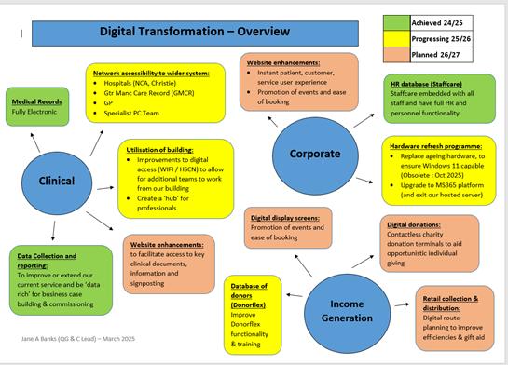

The Data Security and Protection Toolkit (DSPT) (MANDATORY STATEMENT)
Bury Hospice achieved compliance across all mandatory areas of the DSPT in 2024-2025.
The NHS Data Security and Protection Toolkit is an annual online self-assessment tool which enables the Hospice to measure and publish its security performance against the National Data Guardian’s and NHS Data Security standards. The completion of the toolkit confirms that the Hospice has the correct level of data security to maintain the

Significant achievements in IT, Data and Security this year include:
- Full electronic medical records across all our clinical areas
- Enhanced Data collection and improved incident reporting
- Migration of paper personnel records to a digital HR management system
- Development of cyber-security processes and awareness to reduce the likelihood of a data breach
- Installation of Health and Social Care Network broadband connection, which facilitates connection to the Greater Manchester Health Care Record system.

Fundraising

The Fundraising team had a busy and creative year, giving our “Hospice Heroes” new ways to support care for local families. Our events calendar included a 22-mile trek, abseil down Peel Tower, our first Dragon Boat Race, Santa Dash, Golf Day, Christmas Fair, Comedy Festival, and the second For the Love of ball. Looking ahead, we launched two new events for 2025: Back in the Day and a Sahara Trek.
We also held meaningful remembrance events, including a Memory Walk, the Forget-Me-Not display, and two Light Up a Light services, bringing the community together to honour loved ones.
To grow regular income, we launched Sponsor a Nurse, encouraging monthly gifts to support our dedicated nurses. We are delighted by the strong response.
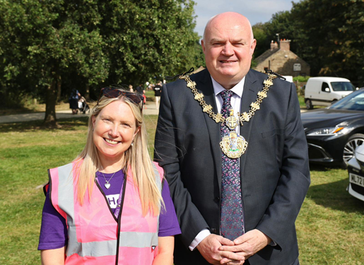
Support from local businesses, schools, and nurseries remained fantastic, with popular activities such as the Golf Tournament, Bunny Hop and Reindeer Run, alongside sponsorships, donations, and Charity of the Year partnerships.
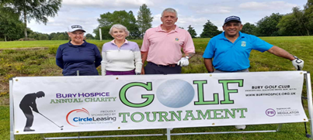

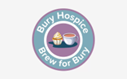
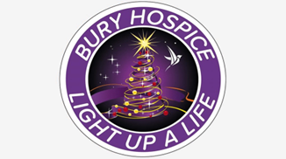


We are deeply grateful to the individuals, groups, and organisations whose generosity makes our work possible.

Retail
The retail department have had a very challenging year on many fronts from donated stock quality to pressures from current cost of living issues. However, despite these challenges, we continue to build on last year’s sales. We have had a very busy year moving our old Radcliffe shop back into the town centre and excitingly, we have opened two new units – a clearance shop in Whitefield and a second furniture outlet in Sedgley Park.
Our shops continue to be popular hubs within the local communities of Bury and are supported by an amazing team of volunteers who not only help us raise vital funds but are the face and voice of the Hospice within their locale. We have held a number of Young Fashion events and themed promotions across the shops which have helped boost sales and been very popular with staff and customers alike.
At the Hospice, we also now have a shop in reception which sells a selection of new goods and gifts alongside old favourites like our Christmas cards.









Financial Summary
The hospice services are offered free of charge to all.
Our total running costs for the financial year 2024 – 2025 were £4,736,681 and the income for the year totaled £4, 780,80. Of which 17% was funded via our contract with the NHS and the remainder generated through the generosity of our supporters, enabling the Hospice to continue to deliver vital services for patients and those important to them.

Our Impact on the Local Community: Beyond Clinical Care
As a vital part of the local ecosystem, our hospice extends its positive impact far beyond clinical services. We are committed to enriching the local community both socially and economically, fostering a culture of giving, employment, and sustainability.
👥 Local Employment and Volunteerism: Our commitment to the local borough is substantial, solidifying our role as a significant local employer and champion of voluntary service.
Significant Employer: We are proud to be recognized as the second-largest voluntary sector employer in the borough. This not only provides stable, local jobs but also contributes directly to the regional economy.
Skill Development and Pathways to Employment: We actively provide support and opportunities for people seeking employment. This includes:
- Offering work placements, internships, and skill-building volunteer roles.
- Providing references and mentorship to help individuals transition into paid employment.
- Volunteer Opportunities: Our extensive group of volunteers is the lifeblood of our organization, fostering strong community connections and providing invaluable skills and experience to hundreds of residents.
♻️ Environmental Sustainability and Recycling: Our charity shops serve as crucial hubs for promoting sustainability and responsible consumption, minimizing waste in the local area.
- Promoting Circular Economy: Through the donation and resale of goods, our shops facilitate a circular economy, ensuring items are reused rather than sent to landfill.
Corporate Social Responsibility (CSR) Partnerships: We actively collaborate with local businesses to help them meet their Corporate Social Responsibility objectives, fostering meaningful connections between the private sector and community needs.
- Corporate Volunteering Days: We organize and host corporate volunteering days, providing local business employees with opportunities to:
  - Engage directly with community needs.
  - Undertake practical tasks that support the hospice environment (e.g., gardening, painting, and organizing).
Mutually Beneficial Engagement: These partnerships not only provide essential support to the hospice but also allow businesses to visibly demonstrate their commitment to the local community, boosting employee morale and social capital.
🛍️ Financial Contribution: through Charity Shops Our charity shops are a recognizable local presence, generating significant funds that are reinvested directly back into patient care services.
Community Hubs: Our shops act as local gathering points, fostering a sense of community engagement and shared purpose.
Reinvestment: All proceeds from our charity shops are used to fund and enhance the specialist palliative and end-of-life care we provide to residents across the borough

Patient Care Support Services

Facilities
At Bury Hospice, the Facilities Team ensures the hospice runs smoothly and safely. Their duties include:
- Building maintenance – repairs and upkeep of the hospice.
- Health and safety – keeping the environment safe and compliant.
- Fleet and equipment management – maintaining vehicles and essential equipment.
- Contractor coordination – overseeing external work and installations.
They help create a safe, comfortable environment for patients, staff, and visitors

Housekeeping Team
The housekeeping team plays a vital role in creating a clean, safe, and welcoming environment for patients, families, visitors, and staff. Their work includes caring for patient rooms, communal areas, and clinical spaces, as well as managing laundry and maintaining high standards of cleanliness and infection control. Through their dedication, the team helps foster a calm and comforting atmosphere that supports the care and wellbeing of everyone in the hospice.

Catering

In 2024/25, the Catering team remained a key part of patient care, working closely with colleagues to adapt meals to changing appetites and dietary needs. Menus are balanced, nutritionally analysed, and tailored to cultural and religious preferences.

Beyond nutrition, food is treated as a source of comfort and connection. Meals are prepared with compassion, supporting dignity and wellbeing, while special occasions are marked with celebratory lunches and afternoon teas—creating meaningful moments for patients, families, and staff.

Volunteering
- Volunteers contributed 53,910 hours in 2024–25, up 7,824 hours (17%) from last year.
- Patient Services saw the largest rise, increasing from 1,412 to 1,820 hours (28%) due to the reintroduction of the role and the successful launch of a new twilight shift, now staffed by two new volunteers. Recruitment in this area remains a priority for next year.
- Garden volunteers contributed 1,761 hours, a 51% increase, as part of Bury Hospice’s entry into the Northwest in Bloom competition.
- Corporate volunteering expanded significantly, with 652 hours across fourteen volunteering days, involving 113 participants from different companies. This compares to just four companies and nine volunteers the previous year.

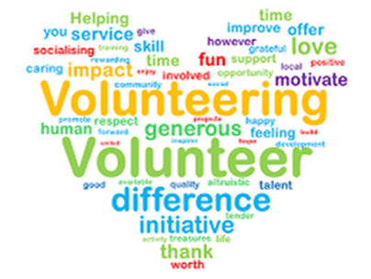
Volunteer recruitment 2024 – 25:

Hospice-based: 34 new volunteers
Retail: 52 new volunteers
Leavers: 17
Total year-end volunteers: 442 – a testament to Bury’s strong community support

Patient Experience
At Bury Hospice, patient quality and safety are our top priorities. We are committed to providing exceptional care that meets the needs and expectations of both patients and their families. To minimize harm and prevent errors, we adhere to evidence-based practices, regularly assess our performance, and continuously refine our processes to ensure patient safety and satisfaction.
We recognize the importance of candour in fostering trust with patients and carers. By prioritizing transparency and accountability, we aim to improve patient outcomes, enhance communication, and cultivate a culture of ongoing learning and improvement in clinical practice.
Here at the Hospice, we place great value on feedback from patients, visitors, and staff. This input is essential for understanding patient needs and enhancing care delivery. It helps us identify areas of strength and opportunities for improvement, guiding targeted changes. Additionally, it supports staff development, offering chances for professional growth. When patients and families feel heard and valued, it strengthens trust and confidence in the care we provide.

What do people say about us?
We use “I Want Great Care” to collect feedback from those who experience our services. Below are some descriptions received to describe care received by our patients and carers following their experience of hospice services.
The median care rating was 4.95, indicating an excellent level of satisfaction, as reflected in the feedback illustrated in the word cloud below.
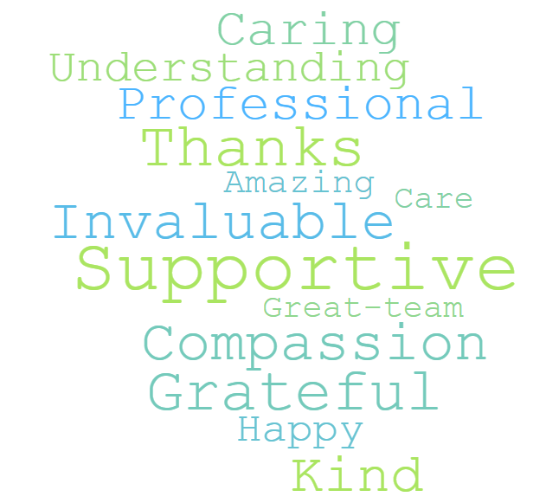

Visitor Feedback
The median service rating was 4.92, reflecting an excellent level of satisfaction, as supported by the feedback highlighted in the word cloud below.
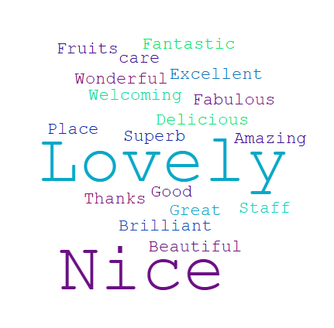

Complaints / Concerns and Compliments
Complaints are integral to upholding high-quality healthcare. The way the hospice addresses concerns reflects its commitment to being both safe and responsive. A robust complaints management system affords the hospice opportunities to restore confidence when expectations have not been met, enhances service quality through feedback, and can prevent minor issues from escalating into more serious problems.
In total there were 19 complaints and concerns raised in the 12-month period, which equates to a 19% increase on the previous year.

The complaints regarding clinical services related to communication by staff (2), quality of service provided (2) and attitude/care provided by an agency nurse (1) and all were investigated, apology was given and all were resolved without requiring external escalation.
We actively seek and value feedback from patients, carers, and all who use our services. Our comprehensive Complaints Policy and Procedure is accessible to all service users, and concerns or alerts are managed with equal rigor.
All concerns raised during 2024–25 were reviewed in consultation with the individuals involved, with reflection and action taken by relevant staff as appropriate. Feedback was provided to those raising concerns, and all issues were resolved without escalation or formal action prior to completion of this Quality Account.
All complaints are recorded in accordance with organisational policy, and we remain fully compliant with the Statutory Duty of Candour (Department of Health, 2014), CQC Regulation 20, and Charity Commission requirements. Duty of Candour training is mandatory for all employees.
We continue to foster a culture of candour, openness, and honesty across the organisation. These values underpin our commitment to safety, learning, and continuous improvement, and are actively promoted at Board level to ensure trust and accountability.
In relation to compliments received the reasons are detailed in the chart below.

The biggest percentage of compliments received relates to clinical care, followed by going the extra mile and communication which is excellent and a testament to the hard work and dedication of our staff and volunteers.

Patient Story

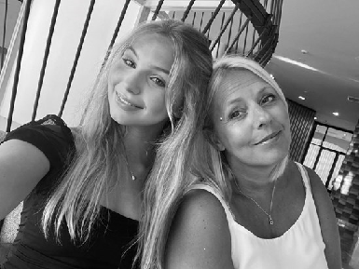

Family turned fundraisers to help the work of Bury Hospice
It is the generosity of our community that helps us to continue providing care and support for people with life-limiting conditions and their families.

Dave’s wife, Amanda died in our inpatient unit in March 2024 after a long fight with cancer. Their daughter Jess was aged 15 at the time.

Six months after Amanda was first diagnosed with bowel cancer in 2018, doctors discovered that it had spread to her lungs.

After Amanda’s final round of chemotherapy in November 2023, the family decided to spend Christmas at home. She cooked Christmas dinner but couldn't eat it, and that night she took a turn for the worse. She was admitted to The Christie on Boxing Day and spent the next few months in and out of the specialist cancer facility in Manchester until March when the doctors suggested stopping all treatment. She was told she had two to four months left to live.
Dave said: “On the day Amanda left The Christie, she said, we're going to Bury Hospice to have a look around. Amanda instantly knew that was where she wanted to spend her final days.ge:

“Bury Hospice felt like a 'home from home'. Amanda spent less than a week in the Inpatient Unit before she died on March 20th.

“She was chatting and giggling when she arrived and was taken outside in a wheelchair to the Japanese garden in the grounds of the hospice before her condition deteriorated. The sun was shining and she said she just wanted to feel the sun on her face."

In her final days, the hospice arranged a hand casting for the family who called themselves the 'three musketeers'. Dave added: "It was one of the last things she saw, our three hands together. She actually saw it the day she passed which makes it even more special.
Supplied)
“Amanda was a beautiful and amazing person who was loved by so many. When Amanda died I felt a deep connection with the hospice and wanted to give something back.

"I couldn’t believe what they did for us wouldn’t be possible without charitable donations, and I am passionate about making sure I help keep the doors open so other families can receive the love and care we did.

"Myself and Jess can never thank Bury Hospice enough for caring for Amanda and looking after us through a devastating time, each and every member of staff are amazing and very special people.”

Dave and Jess have already raised over £27,000 for the hospice including Amanda’s funeral donations and taking part in the hospice’s Memory Walk and the Bury 10k, as part of “Team Mand”.

They have also organised a Monsters Ball to continue raising vital funds. They have proudly displayed a heart on our heart wall in Amanda’s memory.

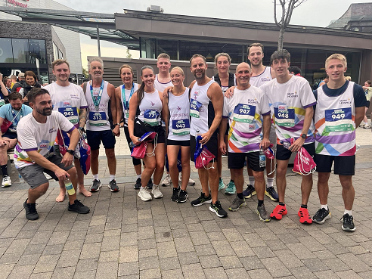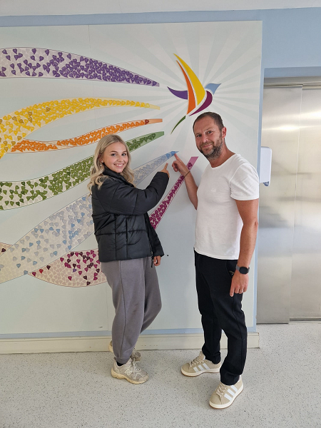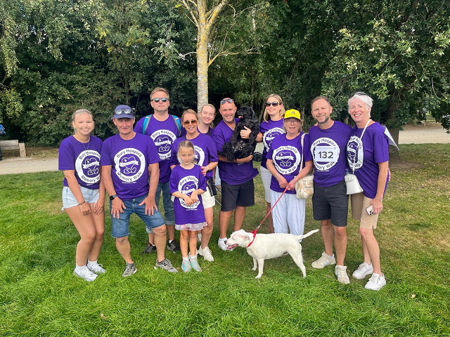

Priorities for 2025 - 2026
SAFE
- Reduce pressure ulcers through targeted training and improved MDT review.
- Reduce falls with a hospice-specific prevention bundle and equipment review.
- Improve medication safety by implementing electronic prescribing and reducing documentation errors.
- Strengthen incident learning under PSIRF.
- Improve data completeness for risk and equality monitoring.
EFFECTIVE
- Review service capacity—IPU bed expansion feasibility and Outreach model optimisation.
- Improve night-time symptom support through clearer pathways with community teams.
- Expand education delivery internally and across the Bury system.
- Advance digital transformation, including full EMR adoption and better use of shared care records.
CARING
- Increase psychological, bereavement and children’s support capacity.
- Improve communication skills across teams, addressing themes from complaints.
- Strengthen cultural competence to support diverse patients and families.
RESPONSIVE
- Improve equity of access through better data capture and targeted community engagement.
- Expand patient-facing volunteer roles and improve volunteer training.
- Deepen partnerships with GPs, district nurses, and hospital discharge teams.
WELL-LED
- Deliver a workforce sustainability plan addressing ageing workforce and recruitment gaps.
- Complete digital and cyber improvements across clinical and corporate systems.
- Strengthen governance and QI loops from incidents, audits, and complaints.
- Grow sustainable income via regular giving, retail optimisation, and corporate partnerships.

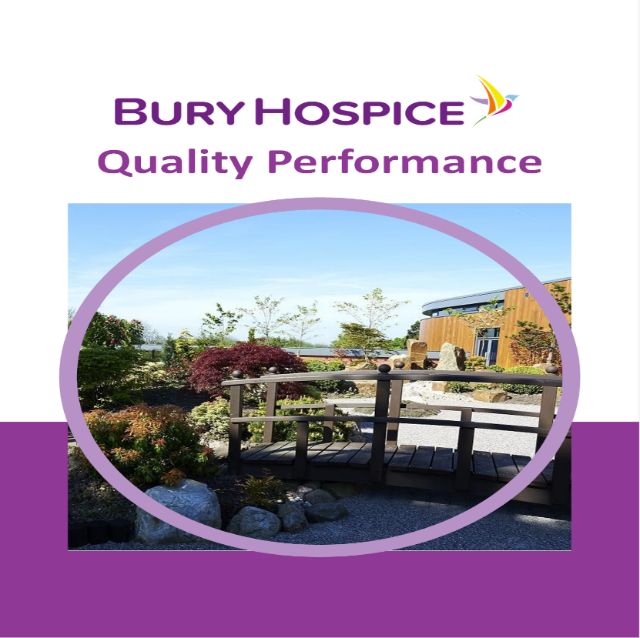

Bury Hospice
Rochdale Old Road
Bury
BL9 7RG
Tel: 0161 725 9800
Email: info@buryhospice.org.uk
Registered Charity 1136843
